**Images for Project Code Individual page**

Chopped-olive-in-salad

(aka file0001133803217)

http://www.morguefile.com/archive/display/102785

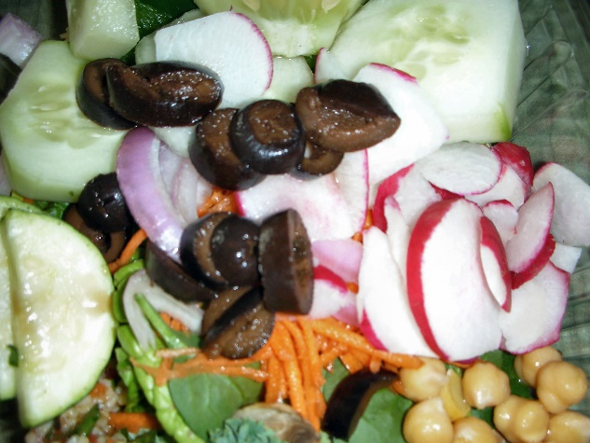

Mixed-olives-in-bowl

(aka food-salad-healthy-black)

<https://www.pexels.com/photo/olives-on-the-plate-5931/>

